Technical Report: Building Gravity Books Data Warehouse
1. Project Overview
The goal of this project is to transform the Gravity_Books transactional database (OLTP) into a structured Data Warehouse (OLAP) to enable efficient business analysis and reporting.

2. Data Modeling & Architecture
We followed the Kimball Methodology to design a Star Schema that consists of::
Fact Table: Fact_Sales (Transactional Fact).
Dimension Tables: * Dim_Books: Contains book details, language, and publishers.
Dim_Customers: Contains customer names and locations.
Dim_Date: A generated time dimension for chronological analysis.
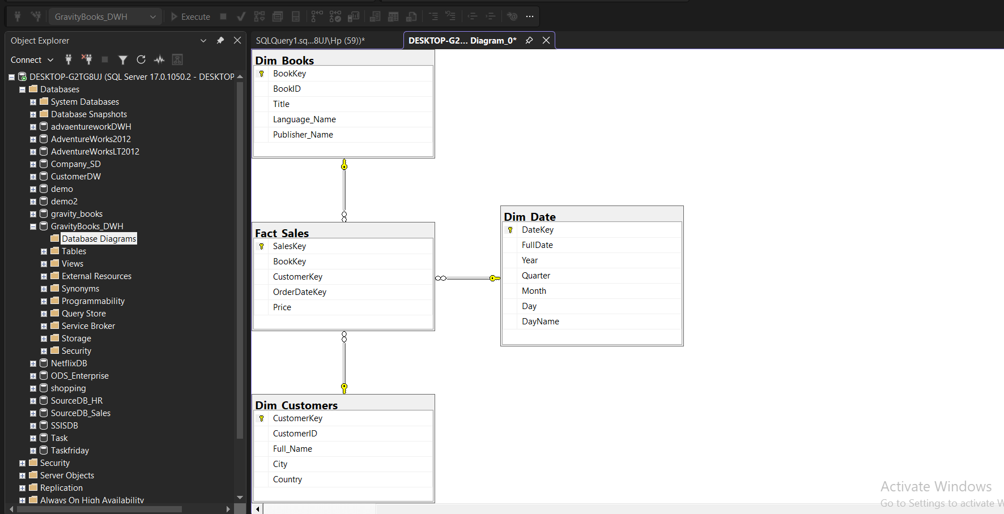

3. ETL Process
The ETL (Extract, Transform, Load) was performed using a combination of Python (Pandas) for initial exploration and T-SQL Scripts for final transformation and loading.
Steps Taken:
Date Generation: Created a static Dim_Date table covering years (1990-2030) to support time-based filtering.
Data Cleaning: Combined first_name and last_name into a single Full_Name field in Dim_Customers.
Surrogate Keys: Implemented Identity Columns as Surrogate Keys for all dimension tables to decouple the DWH from source system changes.
Referential Integrity: Loaded Dimensions first, then the Fact table to ensure all Foreign Key constraints are satisfied.
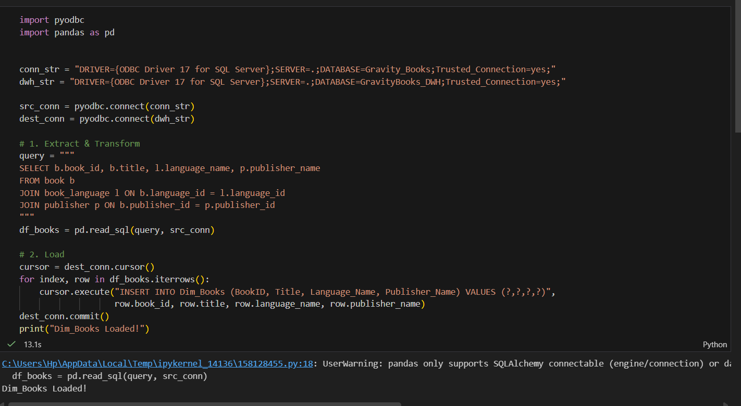
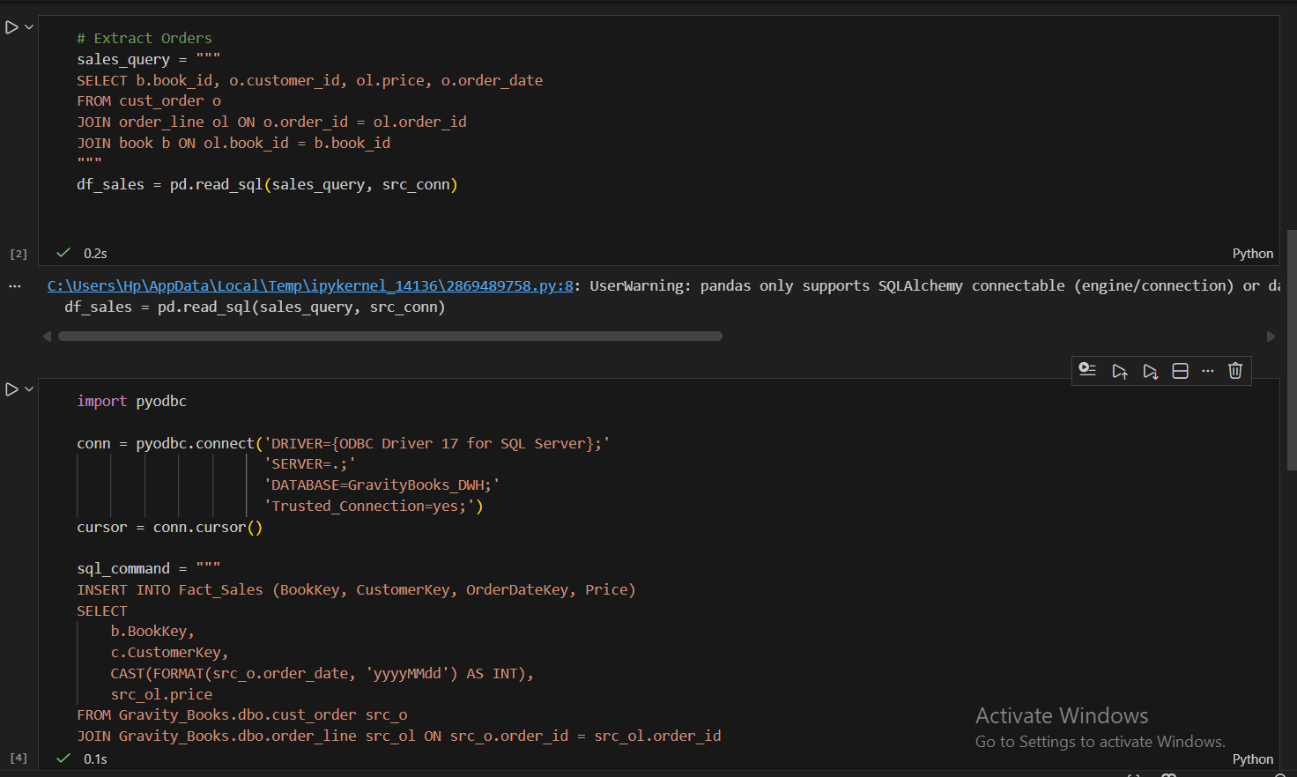

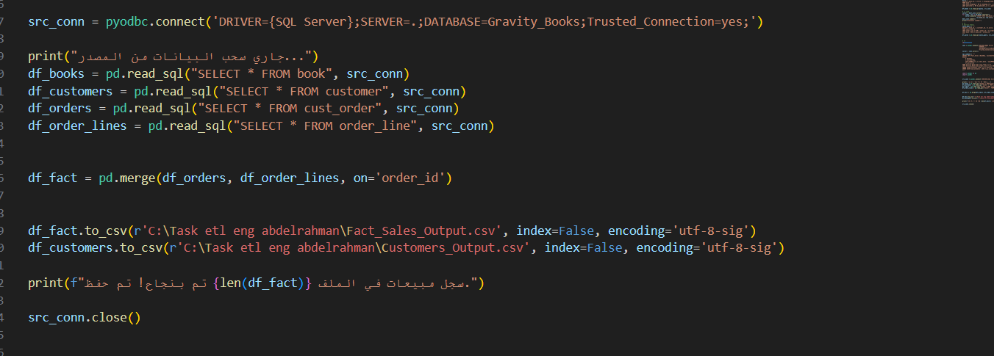

Final Implementation Codes

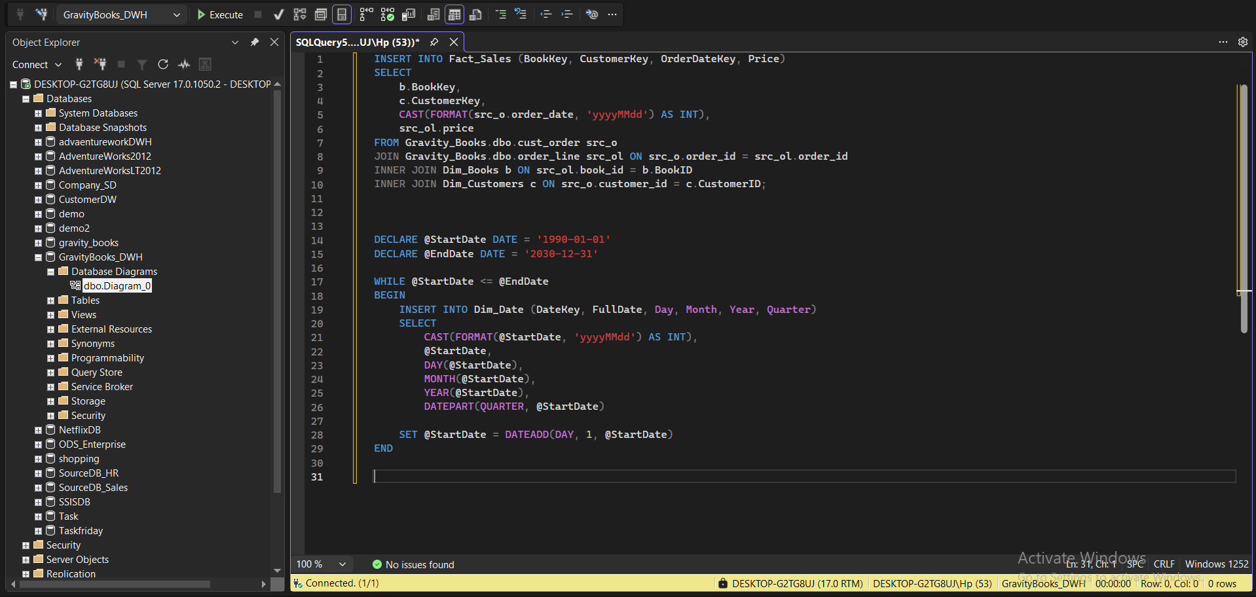
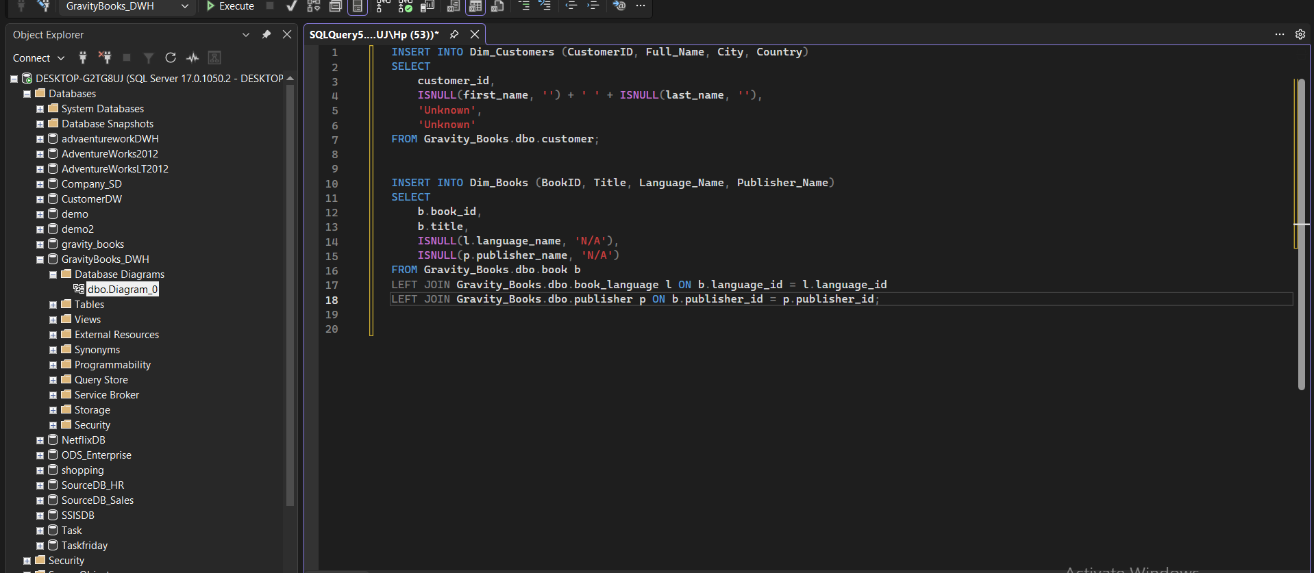

5. Data Validation Results & Sample Analytical Insight
